**Section 3.3 Fixed – Point Iteration**

A fixed point for a function is a number at which the value of the function does not change  
when the function is applied.  
Definition 2.2 The number p is a fixed point for a given function g if g( p) = p.

In this section we consider the problem of finding solutions to fixed-point problems and the connection between the fixed-point problems and the root-finding problems we wish to solve. Root-finding problems and fixed-point problems are equivalent classes in the following sense:

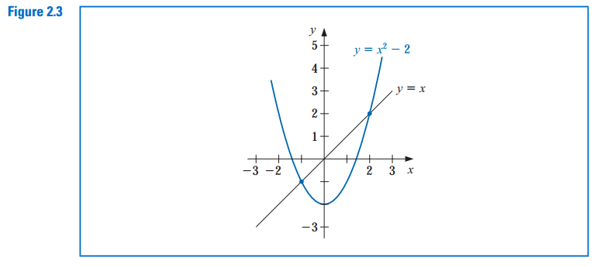

***Theorem 3.3* (i)** If *g* ∈ *C*[*a*, *b*] and *g(x)* ∈ [*a*, *b*] for all *x* ∈ [*a*, *b*], then *g* has at least one fixed point in [*a*, *b*].  
**(ii)** If, in addition, *g’ (x)* exists on *(a*, *b)* and a positive constant *k <* 1 exists with |*g’ (x)*| ≤ *k*, for all *x* ∈ *(a*, *b)*,  
then there is exactly one fixed point in [*a*, *b*]. (See Figure 2.4.)

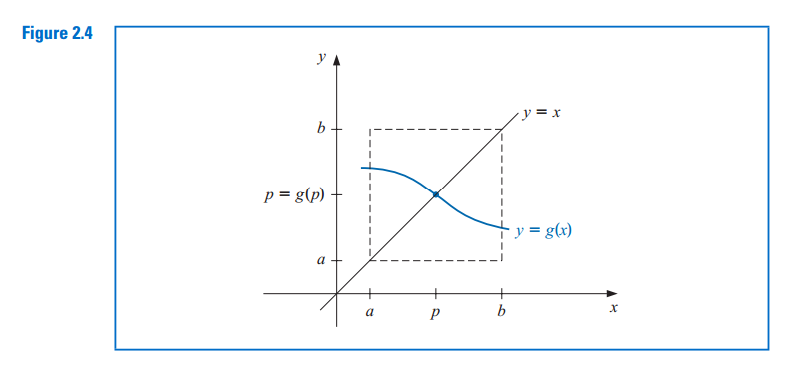

***Proof*(i)** If *g(a)* = *a* or *g(b)* = *b*, then *g* has a fixed point at an endpoint. If not, then *g(a) > a* and *g(b) < b*. The function *h(x)* = *g(x)*-*x* is continuous on [*a*, *b*], with  
*h(a)* = *g(a)* - *a >* 0 and *h(b)* = *g(b)* - *b <* 0.

The Intermediate Value Theorem implies that there exists *p* ∈ *(a*, *b)* for which *h( p)* = 0. This number *p* is a fixed point for *g* because 0 = *h( p)* = *g( p)* - *p* implies that *g( p)* = *p*.  
**(ii)** Suppose, in addition, that |*g (x)*| ≤ *k <* 1 and that *p* and *q* are both fixed points in [*a*, *b*]. If *p ≠* *q*, then the Mean Value Theorem implies that a number *ξ* exists  
between *p* and *q*, and hence in [*a*, *b*], with

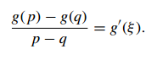

Thus



which is a contradiction. This contradiction must come from the only supposition, *p* ≠ *q*. Hence, *p* = *q* and the fixed point in [*a*, *b*] is unique.

**Example 2** Show that *g(x)* = *(x*2 - 1*)/*3 has a unique fixed point on the interval [-1, 1].  
***Solution*** The maximum and minimum values of *g(x)* for *x* in [-1, 1] must occur either when *x* is an endpoint of the interval or when the derivative is 0. Since *g (x)* = 2*x/*3, the  
function *g* is continuous and *g (x)* exists on [-1, 1]. The maximum and minimum values of *g(x)* occur at *x* = -1, *x* = 0, or *x* = 1. But *g(*-1*)* = 0, *g(*1*)* = 0, and *g(*0*)* = -1*/*3,  
so an absolute maximum for *g(x)* on [-1, 1] occurs at *x* = -1 and *x* = 1, and an absolute minimum at *x=0*

Moreover

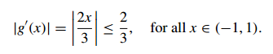

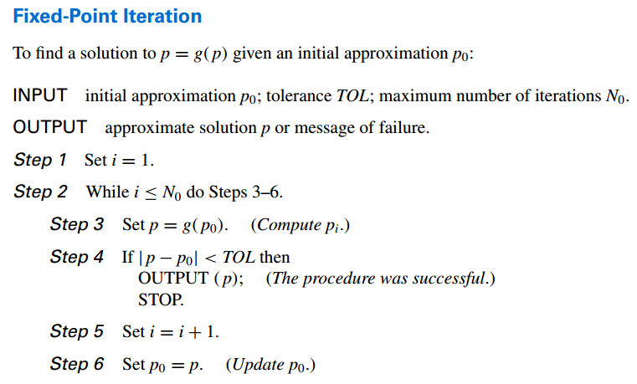

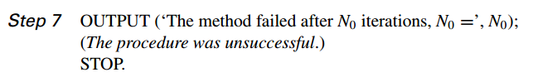

Bài tập

